**FILES AND DIRECTORIES BASICS**

1. **ADMINISTRATOR:**

Home (~):



Root User (#):



Other User ($):



Add user:

* Adding new user to administrator.



Switch user:

* Switching user from root user to devarun user.



1. **DIRECTORY:**

Creating a new directory:



Display a list of directory by using ls command:



Creating a multiple Directories:

* Creating a multiple directory in a single mkdir commands.

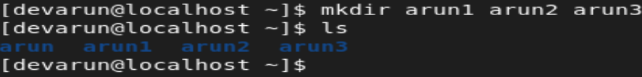

Change Directory:

* cd .. 🡪 Previous Directory
* cd 🡪 Home

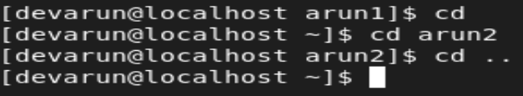

1. **FILES:**

Creating a file:

* Creating a file by using touch command.

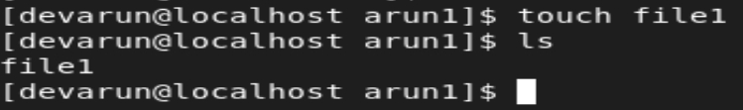

Creating multiple files:

* Creating multiple files in a single touch command with ls -l command.

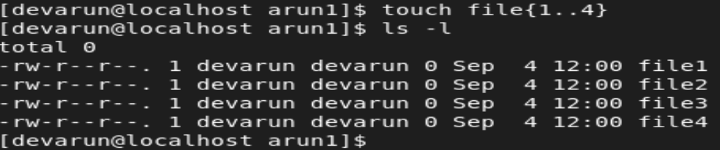

1. **PATH WAY DIRECTORY(PWD):**

* PWD shows the path of the file.

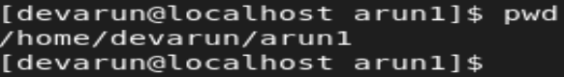

1. **CREATE MANY DIRECTORIES:**



* Creating multiple directories by using mkdir commands.

1. **REMOVE MANY DIRECTORIES:**

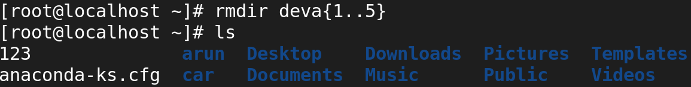

* Removing multiple directories by using rmdir commands.

-r with request:

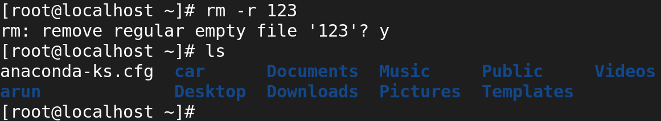

-rf with request:

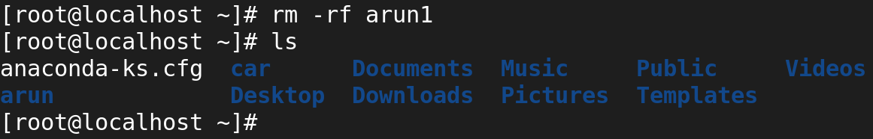

1. **CREATE MANY FILES:**

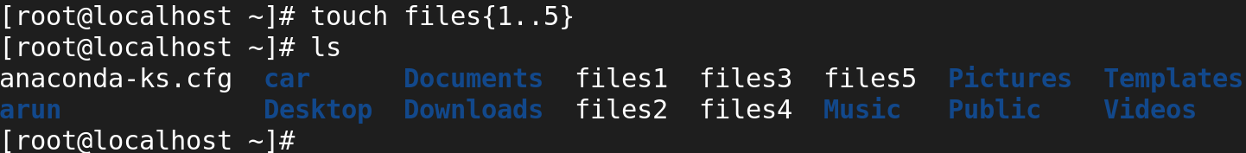

* Creating multiple files by using touch commands.

1. **REMOVE MULTIPLE FILES:**

* With Permissions:

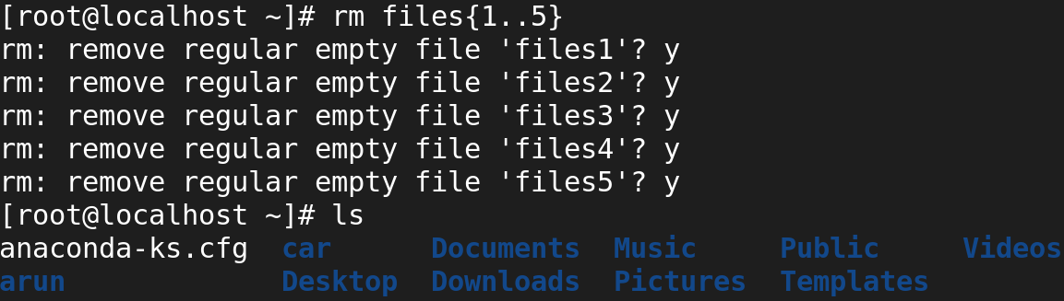

* Without Permissions:

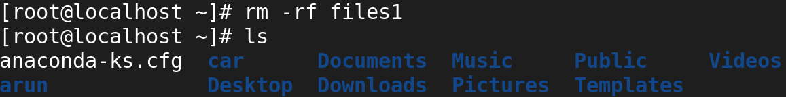

1. **PARENT DIRECTORIES:**



* Creating parent directories by using mkdir commands and -p options.

1. **RELATIVE PATH:**

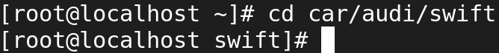

1. **ABSOLUTE PATH:**



1. **CAT COMMANDS:**

* Use CAT Command to view file.



* > [Overwrite]:



* >> [Append]:

